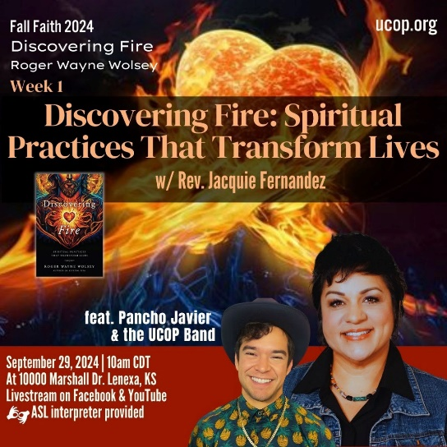

|  |
| --- |
| **Discovering *Fire*: Spiritual Practices That Transform Lives by Roger Wolsey** |
| U n i t y C h u r c h o f O v e r l a n d P a r k Fall Faith 2024  **Week 1: Introduction & Chapter 1 Diagnosis Death** |

1. Wolsey offers this quote by Leland Val Ven de Wall, “The degree to which a person can grow is directly proportional to the amount of truth he can accept about himself without running away.” (page xxi) Then follows it up with this statement: An authentic life – a truly spiritual, fully human life – involves, and indeed requires, discomfort, mess, and suffering. Authentic, spiritual living is messy, occasionally painful, and chaotic. God/Spirit/The Divine/The Sacred is in our chaos.

What is your relationship with self-acceptance? Have you developed coping mechanisms for ‘running away’ from yourself? Have you overcome those tendencies or are you a ‘work in progress’? How about mess? Do you prefer the tidy and simple way of being or are familiar with your inner chaos? Wolsey offers that “the way to full, whole-hearted living necessitates openness to messiness and patient suffering – oftentimes extended periods of each.” Do you agree?

[Write entry here]

### 2. Context is everything! In the introduction, Wolsey outlines the purpose of the book and his desired impact. *“It is written to help fellow humans, religious and non-religious, do our work in knowing ourselves, loving ourselves, loving others, and living lives fanned by the mystic fires of love – through practices over which no religion or spiritual path has a monopoly.”* (page xx) And in chapter 1, Break It Down 1 (page 3) invites us to consider spirituality like playing an instrument alone, while religion is like playing an instrument with a band/orchestra. How do you feel reading this? Do you identify as religious? Non-religious? Spiritual? Agnostic? As we begin the journey, reflect on how you feel in terms of familiarity with the phrase *“living lives fanned by the mystic fires of love.”* Are you eager? Nervous? Hesitant? All aflame? Without judgment, take a personal inventory of your feelings, notice your body and how it feels to be in this reflection. *Regardless of how you feel, remind yourself you only take the next step if you want to and only as fast (or slow) as feels nurturing.

[Write entry here]

3. *“Jesus is my primary love language. Jesus was a fellow human, a fully embodied divine-human spiritual being, who did his work, owned his fear, and found courage within to enter fire – and risk being transformed by smelting, tempering, refining, forges and crucibles.”* (page 6) While Wolsey states he is at a point in his life that he doesn’t ‘have to be Christian’ he still identifies as such and even calls Jesus his primary love language. He describes the distortion that has happened in churches that emphasize knowing the right things about Jesus over knowing the *“gracious teachings and loving practices of Jesus that helped him to be who he was.”* (page 6)

What does this bring up for you? What is your primary love language? What do you think about Jesus; how relevant is the Jesus story to your life? Have you experienced the distortion that Wolsey describes between an emphasis of knowing the right things about Jesus vs. his gracious teachings and loving practices?

[Write entry here]

4. The words of luminary Fr. Richard Rhor are included in this book, *“If we do not transform our pain, we will most assuredly transmit it.”* Wolsey goes on to include a more blunt version of these words that is often shared, *“If you don’t heal what hurt you, you’ll bleed on people who didn’t cut you”* and yet another variation, *“trauma is not your fault, but healing is your responsibility.”* And then he offers this medicine: *healing is best understood as a team effort.* (page 17) This idea expands the responsibility of healing into the community, as our collective responsibility to stay connected to one another.

Have you had an experience or awareness (perhaps in hindsight) of personal trauma or pain that negatively impacted those around you? Did your community show up for you in a helpful way? Rather than remember with judgment, how would it feel to apply the gracious teachings of Jesus to your past self or to the community/family/friends who may have left you alone in your pain? Does the idea of sharing the responsibility of healing seem appealing to you? If yes, how? If no, name how it feels to you and why. *Apply self-compassion to your authenticity.

[Write entry here]