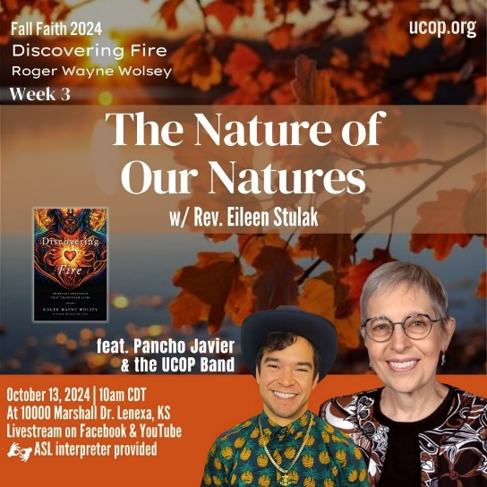

|  |
| --- |
| **Discovering *Fire*: Spiritual Practices That Transform Lives by Roger Wolsey** |
| U n i t y C h u r c h o f O v e r l a n d P a r k Fall Faith 2024  **Week 3: Chapter 3 The Nature of Our Natures** |

1. Wolsey offers that society has us being more ‘human *do*-ings’ rather than ‘human *be*-ings.’ He offers the fire of *embracing* Solitude as a way to practice and presence being. (page 60-64)

Reflect on whether you are an introvert, extrovert, or ambivert? What gives you energy and what depletes you? *“Humans are social animals, and we thrive most in some form of relational connection and community with others.”* (page 60) What is your relationship with Solitude? Do you want more? Less? How does it feel to consider embracing it as a spiritual practice?

[Write entry here]

2. BE-ING in NATURE (pages 70-74)  
  
Many peoples around the world believe there are specific sacred locations on the planet. The early Celtic Christians called these “thin places,” where Spirit can be experienced more keenly and directly. (page 71)

Can you think of anywhere you have been that felt notably sacred? It could be a childhood treehouse or rooftop, a place you visit often or only ever experienced once. Describe how it felt to be in that location- can you conjure those feelings in your body now as you remember?

[Write entry here]

3. Shadow work is one of the fires Wolsey describes at length. It is a lifelong process to work with the shadow (unconscious parts being). Review the Chaves list on page 92, “9 Signs You’ve Done Shadow Work.”

Reflect on one or two that are calling your attention. *Remember to do so without judgment. This is for your awareness and soul unfoldment.* Set a timer for 5 minutes and, without over-thinking it, write about these one or two opportunities. For example, if you choose 1. You can laugh at yourself as an opportunity, use inquiry without over-thinking to explore why this is calling you. Use a question like, *what would happen if I laughed at myself*; or use a prompt like *I don’t laugh at myself because…;* then dig a little deeper *I was laughed at and felt…*

This is meant to be a free-flow writing exercise. Simply write whatever comes to mind- allowing that which is ‘in the shadow’ to come to the light of your awareness. Try not to judge your thoughts or words as right or wrong and let your inner world speak for itself. Stay curious and gentle. Try to stay with it for the entire 5 minutes. Then spend a few minutes reviewing what you’ve written with compassion and self-love. Thank your soul for bringing this to light and make a commitment to work with the opportunity over the next few weeks. Notice if the result is that you freely do whatever the prompt is, in our example, you would notice laughing at yourself when you least expect it.

[Write entry here]

4. There are 13 fires in chapter 3! Choose a few to practice throughout the week and log your experiences here. Try to explore something completely new if that is an option for you, or engage the practice in a new way. Here are the 13 in order for easy reference:  
*Solitude, Yoga, Yoga Nidra, Labyrinths, Be-ing in Nature, Earthing/Grounding, Authentic Relating, Circling, Shadow Work, Winnowing, Ecstatic Dance, Kirtan Singing, Somatic Portalling*

[Write entry here]