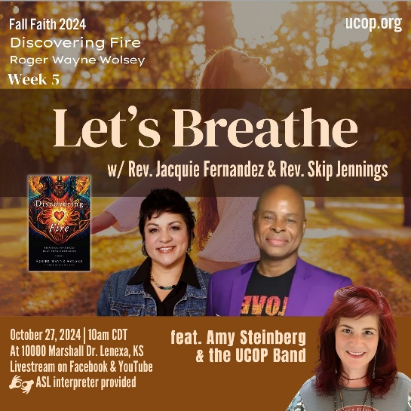

|  |
| --- |
| **Discovering *Fire*: Spiritual Practices That Transform Lives by Roger Wolsey** |
| U n i t y C h u r c h o f O v e r l a n d P a r k Fall Faith 2024  **Week 5: Chapter 5 Let’s Breathe** |

1. In chapter five, Wolsey explores the fire of breathwork practices. These practices, depending on the tradition, can include breathing techniques that “induce a semi-psychedelic altered states that often leave people feeling ecstasy, connection with the Divine, union with the universe, and/or emotional healing and increased sense of serenity and contentment.” (page 123)

Reflect on times when you have either used breathing techniques to induce such a state, or have brought your awareness to your breath. Bring to your awareness a memory of such and describe how it felt physically, emotionally, intellectually, and spiritually. You may have more than one experience that comes to mind, try to focus on just one. Try not to practice the technique as you journal, but rather reflect from memory.

[Write entry here]

2. With a focus on the breath, a shift can be created in us, even a connection with a feeling sense of the divine, or the Holy Spirit. Wolsey describes this as our “mystic union and communion with, and in, God as sacred children and expressions of God.” (page 129) He then shares a quote by Meister Eckhart:

*The eye through which I see God is the same eye through which God sees me; my eye and God’s eye are one eye, one seeing, one knowing, one love.*

Take a few minutes, consider setting a timer for just a little bit longer than feels comfortable, and read the above Eckhart quote out loud a few times, then allow your eyes to close or soften and begin to focus on the breath. Before you begin, read through these prompts for awareness and feel free to reference them after you begin.  
*You might begin with a few deep breaths, and then let your breathing return to its natural rhythm. Consider the temperature of the air as it passes through your nostrils. Notice if you feel an easy flow of breath or a struggle Sense your breath as it takes up space in your body, feeling the sensation of your rib cage expanding, your diaphragm, your belly, your back. Notice the sound of your breathing activity. If your mind wanders, return its focus to the breath.*

Now reflect again on the above Eckhart quote. In the activity and awareness of your breath was an opportunity to be totally present. The breath is always in the moment. This is why it takes us into deep union and communion with the divine. Describe how it felt for you to be totally present. What thoughts did you have? How did you feel in your body? Did you feel an encounter with the Holy? Did you feel resistance? There are no right or wrong answers, only reflection and awareness. Receive the gift of your awareness as you write below.

[Write entry here]

3. Watch this video on [3 Effective Breathing Exercises](https://www.youtube.com/watch?v=AkOZKsB4y3w) (Pranayams)

Note: There is a bonus fourth exercise in the video!

Choose one or more of the exercises to practice daily, make note of the purpose of each. Journal about the experience below. What do you notice after three days compared to after seven days in this practice? Describe how you felt in the learning curve if these practices are new to you. Explore the sensations in your body throughout and reflect on these in your writing. Be sure to give yourself gratitude for the commitment to this practice, for the breath of life, and for your innate connection to the Divine.

Quick reference:

1. Nadi Shodhan (balance and purify energy channels in the body)
2. Bhastrika (“yogi coffee”; energy boost; begin day with this exercise)
3. Bharmari (activate frontal lobe of brain; practice before sleeping)
4. Slow Breathing (aka Box Breathing; calm instantly; reduce anxiety)

[Write entry here]