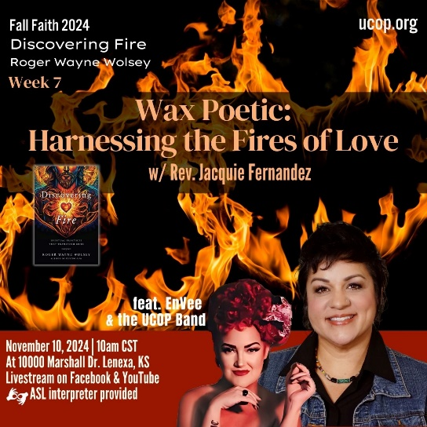

|  |
| --- |
| **Discovering *Fire*: Spiritual Practices That Transform Lives by Roger Wolsey** |
| U n i t y C h u r c h o f O v e r l a n d P a r k Fall Faith 2024  **Week 7: Chapter 7 Powerful Prose & Poetry** |

1. In chapter 7, Wolsey states: *Words have power and poetic words move us greatly. We like being moved – and we need it.* (page 202)  
  
What is your relationship with poetry? Does it move you? Do you write prose or poetry? Are you an avid reader/listener of it? Is it completely foreign to you? Do you have favorite poets or poems?

Make time here to reflect on your relationship with poetry and write about it, include feelings that come up as you reflect. Have you been moved by poetry before and is there a particular time that stands out for you? Perhaps include a favorite poem or names some poets whose works you have enjoyed.

[Write entry here]

2. On pages 207-209, Wolsey explores the relationship between poetry/prose and *Imago Dei –* being born in the image of God. Wolsey says that poetry reminds us that we aren’t alone in our feelings, in our suffering, in our yearnings and states that “*poets and spiritual writers -both living and dead- are part of the cloud of witnesses who surround me and who I feel deep communion and fellowship with*.” (page 209)

Wolsey shares an Easter Letter of His Holiness to Artists (April 4, 1999) by Pope John Paul II (pages 207-208). In this letter, the Pope writes that “Beauty is a key to the mystery and a call to transcendence. It is an invitation to savor life and to dream of the future.” Wolsey reflects from this letter that what makes humans have *Imago Dei* are our capacities to love and to create and that to create is our birthright. What are the ways (writing or otherwise) that you express your capacities to love and to create?

[Write entry here]

3. Choose one or both of these exercises to experience the fire of poetry or prose.

a. Choose one of Wolsey’s poems in the book or any poem that you want and read it using the fire of *Lectio Divina* from chapter 2 (can review on page 35). This is a way to engage the practice of contemplative prayer and open to the power of creativity to move in you. This can be a daily practice, using a different poem each day. Be sure to journal your reflections.

b. Write a poem or prose of your own! This can be a daily practice with a new piece each day, or you can work on the same piece throughout the week. This is a time to practice the power of your own creative birthright and let your creativity flow- be it a trickle or raging river! Consider using this website of [100 Phenomenal Poetry Prompts](https://jerichowriters.com/100-poetry-prompts/)  to help get your creative juices flowing! Remember to practice nonjudgement and allow yourself to write authentically, simply, honestly without judging whether it is good or bad. *Just write! For those in small groups, consider sharing your work with your group and/or what the process was like for you.*

[Write entry here]